# Christopher Hyde

# Southern New Hampshire University

# IT-420: Advanced Info Systems Implementation

# Module 7-2: Final Project

# Project Closure Document

# 12/15/2019

**Table of Contents**

**I.** **Introduction 3**

Problem Statement **4**

Significance **4**

Objectives **5**

**II. Verification Plan**

Feedback Plan **5**

Criteria **6**

Test Cases **7**

**III. Project Closure**

**Postmortem Summary 7**

Methodologies **8**

Method Evaluation **8-9**

Risk Mitigation **10**

**Project Status**

Objectives **10**

Issues **11**

Alternative/Recommendations **11**

Communication **11**

**Future Enhancements 12**

**Implementation Support 13**

**Maintenance Plan 13-14**

**References 15-16**

**Appendix 17-24**

**Introduction**

GasBuddy was founded in 2000 as a social network community where users could post gas prices in their area, allowing others to find the best gas prices nearby. Before long, it had a client base that spanned the US, Canada and even Australia. They also drew consumers in with free tools such as gas price charts, an outage tracker, and a trip cost calculator. As time went on, they increased revenue by running ads on gas-focused websites expanding to an even wider market. Within the first year, GasBuddy.com had spawned 110 regionally focused sites across the US and Canada that reported gas price information within local markets. Not long after, it reached 250 sites including bostongasprices.com and sanfransiscogasprices.com. It remained free to its customers by selling ads on its corporate and regional websites.*(Huang, 2018)*

In 2010, they transitioned into a mobile app for iOS and Android smartphones, known as GasBuddy 2.0, which proved to be quite successful prompting 60 million downloads. However, it was still using pretty much its original design and infrastructure. Then, in 2016, a new CEO was brought in to revamp the business. Walt Doyle transformed the app further still (GasBuddy 3.0) by adding a payment transaction system within the site called “Pay with GasBuddy” which also offered users the opportunity to earn points towards a $100 gas card drawing. *(Huang, 2018)*. At this point, the GasBuddy service was still free, but they struggled to cover costs and had to begin charging a premium for users. While the revenue generated from the subscription fee allowed them to further their business, the competition was still offering theirs for free.

**Problem Statement**

The problem GasBuddy faced was that by the end of 2017 their active userbase was just over 2.2 million. *(Huang, 2018)*. Without big changes, the company would remain stagnant in its growth. To do this they would need to broaden their horizons and explore several sales channels of opportunities; thus, expanding their customer base to ensure future growth. The platform is already there so they would just be building on it. In that way, they were not starting from scratch. If GasBuddy is to maintain a sustainable and competitive advantage in the market, they need to make profitable changes - but without impacting their existing client base. The changes should be such that the infrastructure is in place for expandability towards future endeavors such as exploring more of the international market and domestically related markets like auto repair facilities.

**Significance**

This problem holds certain significance for me at various levels. The GasBuddy app itself appeals to me in general since as a family of four on a budget, we are always looking for cost savings on our expenses. Being able to quickly go to an app on our phones that tells us where to find the cheapest gas is a great benefit. That idea in conjunction with the use of technology, such as a laptop or smartphone, and the addition of GasBuddy is a winning combination.

I am also always impressed by startup companies that not only find a niche but experience rapid growth and success in a relatively short amount of time. In addition, that fact that it combines a means of saving money with the technology aspect interests me even more. Even still, there is always room for improvement and expansion.

I feel that such a company deserves continued success and growth. In order to do that, changes must be made to propel it to the next level. As a Networking and Communications major, the data storage needs, and security of customer’s personal information is of great importance to me as I move towards a career in IT. I would hope that the success of this project would illustrate my determination to make that a reality and in doing so, create a bright and successful future for the GasBuddy company.

**Objectives**

The scope of this project is not huge, as in a complete overhaul, but at the same time it is not a minor one either. The goal is to make changes to the app that are sizable enough to expand the user base and increase revenue, but not be cost prohibitive. The main objectives of GasBuddy 3.0 will be the addition of certain filters and search functions for brand name gas stations and charging stations for electric vehicles. Next, will be a brand-new feature aimed at the commercial fleet vehicle market. Perhaps the most involved objective to accomplish is moving to a cloud-based platform for increased data security and expansion capability. Since it is manageable, I believe this could be accomplished in the reasonable timeframe of less than 4 months.

**Verification Plan**

The system verification plan covers the test methods and strategies necessary to ensure the functionality and security of the GasBuddy app. It consists of obtaining feedback from stakeholders as well as users, establishing criteria for acting on that feedback, and conducting test cases for the system.

*Feedback Plan*

The system validation plan is how the stakeholders will determine if the project meets the customers’ requirements and is worth proceeding ahead. This validation would be based on both customer feedback as well as from stakeholders; weighted more heavily on the latter. There are various ways to gather customer feedback for a project such as this. Surveys can be incorporated on the mobile website for quick “on a scale of 1 to 10” polls. For longer feedback issues, users can use an email form to relay specific concerns or issues in greater detail than a simple survey can. Social media is another great way to elicit candid feedback. It also acts as great word-of-mouth advertising if users rave about the app. However, it can work negatively as well if people experience problems. Tracking the search habits and behavior of the users on the website through web analytics can assist in determining which aspects of the app would need improvement *(Hill, 2019).* Internally, regular stakeholder meetings would take place at pivotal phases of the project where they and project members would meet face-to-face and discuss the current status of the project and exchange ideas.

*Criteria*

Certain criteria will be used when determining the priority level of the feedback collected and whether it is actionable and relevant to the project. First, we would gauge it by whether the feedback constitutes a negative or a positive impact on the business. Most likely if the issue found will cause financial problems it would go into the negative category. Then a cost benefit analysis would be performed and decide what resources should be allocated to it. Obviously, feedback that uncovers a more severe threat would take a higher priority than those that don’t. On the other hand, there may even be feedback that positively enforce an existing feature, qualifying its existence. From a stakeholder’s standpoint, they would have the ultimate say in what course of action should be taken.

*Test Cases*

Following the design phase, the plan would transition to a pre-production environment “test system” that would allow the software and hardware functionality to be put through their paces. Those involved with these cases would need to make sure they fall within acceptable performance criteria which can then be used to establish guidelines that the project team would need to adhere to. This is known as specification testing. Another approach is through risk-based testing is where certain scenarios or failures are carried out to see how the system reacts and recovers. *(Bhagwat, 2019)* All of this ensures functionality of the project.

After these test cases, the stakeholders and project management staff can review these findings along with feedback and verify that they align with the proposed system requirements. Once they get the signoff’s qualifying the effectiveness of the system design, they can then proceed to the production phase.

**Postmortem Summary**

*Methodologies*

In this project, the methodology and techniques I used followed a two-level approach. First, I performed a **SWOT** analysis, addressing GasBuddy’s **S**trengths and **W**eaknesses as well as potential **O**pportunities and the **T**hreats they would face.

**S**trengths – GasBuddy has a strong, recognizable brand.

**W**eaknesses – Scalability and Computing Power.

**O**pportunities - Expanding GasBuddy’s market position into the business client area.

**T**hreats – Competition from other well-known apps such as Waze and GoogleMaps

For the second level, I enlisted the Agile methodology to organize the project development into clearly defined yet flexible steps. This served as an ideal project management methodology for this undertaking. I chose it over a Waterfall methodology because, while waterfall is straightforward, it is both time consuming and rigid in its approach. It requires the completion of each step before moving on to the next. A Sequential methodology works for less complex systems with minimum requirements, but it requires that all of the requirements are defined up front and does not allow for corrections midstream. The Agile methodology puts the emphasis on individuals and interactions. Separate teams work independent of each other and there is an open dialogue amongst the team members rather than orders being dictated from the upper-management members. The teams can brainstorm ideas and features and benefit from real-time feedback; not only internally but from customer feedback as well. (De Los Angeles, J, 2018)

*Method Evaluation*

The Agile methodology served the project very well. It allowed for us to maneuver through certain areas and make adjustments when necessary. Agile flows very nicely with the six phases of the System Development Life Cycle (Research Phase, Design Phase, Development Phase, Testing Phase, and Maintenance Phase.)

**Phase 1 (Research Phase)** - The project team is assigned its members (see Appendix A), the scope of the project is defined and the requirements and the associated costs for the project are assembled. The risks involved in the project are also identified in a risk matrix specifying the potential severity of those risks.

**Phase 2 (Design Phase)** - Here is where any hardware and software necessary for the project is gathered. This can vary depending on deliveries from the respective vendors. From there, the new app is designed, and the software build is configured.

**Phase 3 (Development Phase)** – In this phase the back-end and front-end changes take place.

**Phase 4 (Testing Phase)** - This includes software functionality, hardware, and upload/download speeds.

**Phase 5 (Implementation Phase**) - The coding and debugging of the mobile app site begins, it is uploaded, and then deployed to the public.

**Phase 6 (Maintenance Phase)** - Any customer issues with the new version are addressed, system maintenance is performed (as needed), and the entire process is documented from start to finish.

With regards to tools used during my project, I used a Work Breakdown Schedule to put the tasks in a hierarchal form providing an ideal tool for the team to use to work together. This assured nothing gets missed and also helps with resource allocation. (Markgraf, 2019) I used Microsoft Visio for my Work Breakdown Structure, and I incorporated a Gantt Chart (see Appendix B) which listed all the deliverables and the date ranges they cover. In the Gannt chart I also break down the dependencies. Some require the task preceding it to be completed while other tasks or phases can be done in parallel to others. I chose Microsoft Visio for its ease of use. Microsoft Project is more elaborate (and costly) as it is an entire project management suite. However, it does require quite a bit of training. For the documentation portion, I used Microsoft Word.

*Risk Mitigation*

The project faces the challenges of staying within budget, personnel scheduling commitments, data security issues, and bandwidth issues due to an increased customer base (see Appendix C). Each carry a downstream effect to either performance, cost, or capability. If the project is not on schedule for various reasons, it could affect the various groups involved. Staffing issues in terms of scheduling conflicts, vacations and those who are out sick, will change the length of the project. Next, sensitive company data and customer personal information data could be compromised during the cloud migration unless strict protocols are in place during deployment to protect the security of the system. Lastly, bandwidth issues could slow down the application for customers unless bottleneck issues are mitigated. Categorizing and addressing critical problems is important to maintaining the timeline.

**Project Status**

*Objectives*

The GasBuddy 3.0 project has three main objectives. One is the addition of certain filters and search functions for brand name gas stations and charging stations for electric vehicles. Next, a brand-new feature aimed at the commercial fleet vehicle market. The third and perhaps the most challenging one to accomplish is moving to a cloud-based platform for increased data security, faster uptime response and future expansion capability.

From a specific deliverables standpoint, the project will ultimately result in the following improvements:

1. Top Tier Gas locations, price charts, and search filter (see Appendix D)
2. Charging Station locations, price charts and search filter (see Appendix E)
3. A fleet truck tracker and gas mileage dashboard (see Appendix F)
4. Cloud-based storage utilizing OpenStack and managed by Rackspace (Brown, 2016)

*Issues*

Thankfully, objectives were met and the we came in just under budget. The tasks in the timeline (for the most part), were executed correctly and on-time. Some took longer than expected, but this was compensated for by having other tasks completed more rapidly than originally expected. Also, through effective time management, we were able to strike a balance between stakeholders and team expectations.

*Alternative/Recommendations*

Fortunately for the project, no major modifications or shortcuts were required during the various phases with the exception of adding third-party testers of the project to assess any issues with the application in both the mobile and desktop environments. This fresh set of eyes provided further insight on necessary changes and allowed the team to develop and prioritize the changes. These adjustments were based in part on feedback from other project creators.

*Communication*

A project status report elicits transparency to the stakeholders. It details what the tasks are, which of them have been completed (and when), and what is next on the agenda. It also includes potential issues and risks, the objectives being met, and what’s coming next. To accomplish this with GasBuddy, a project status report (Appendix G), was used. It’s presented in an easy to read and understandable format that is thorough but not overwhelming. Emailing this to the team weekly, in conjunction with the status meetings was extremely effective. The report contains the standard accomplishment status and timeline, as well as a change request section. Section 5 identifies risks and issues and requires an action be taken to address them. Best of all, it assigns ownership for someone to be responsible to execute that action. There is a Risk/Issue history log to note previous problems, and how they were dealt with, which is beneficial to avoid redundancy. The Earned Values chart tracks the planned costs associated with the project and whether there had been variances in those costs, from week to week. This serves to prevent the project from going over budget but does so on a weekly basis so that corrections can be made to get back on course.

**Future Enhancements**

The move to the cloud-based infrastructure through Openstack will further facilitate future enhancements as it will make it significantly more scalable than in its previous form. It would certainly allow for more clients as well as multiple devices per client (i.e. tablets, laptops) and be able to compensate for high user request loads. Other future enhancements could include social media integration for sites like Facebook and Instagram. In addition, there could be a linkage to the auto manufacturer’s recommended maintenance schedules for the customer’s specific vehicle. The GasBuddy app would let the customer know when their vehicle is due for upcoming services by sending an email or text alert. A “chat” button feature allowing real-time assistance between GasBuddy and the customer for technical questions. The new design has the added benefit of not requiring a dedicated IT manager on staff and therefore save on payroll.

**Implementation Support**

Once the coding and debugging aspect of the GasBuddy app takes place, it will be deployed to the public on the Go- Live date of Jan 20, 2020. There should be minimal downtime expected during the migration, if at all. The implementation plan consists of several parts:

* **Data Validation -** to ensure the data being moved is correct prior to migration
* **Software Installation -** the software is installed to the live environment
* **Hardware Configuration -** hardware is configured, undergoes stress and burn-in testing
* **Data Migration** - where the actual movement to the cloud environment will take place using a secure connection (SSD) and encrypted to Payment Card Industry Data Security Standards (PCI DSS) through Rackspace
* **Error Checks During Migration –** Several tests for errors while upgrading are performed
* **Support Services Training –** The support staff is trained for customer assistance
* **User Support Documentation –** FAQs and other manuals are made available
* **Quality Assurance Process –** An 8D (Eight Disciplines) quality improvement process is initiated. Any problems are identified, analyzed, and a corrective action plan implemented.

**Maintenance Plan**

To ensure the reliability, as well as security and availability of the GasBuddy network, a maintenance plan will be implemented. It includes a 24/7 real-time monitoring of the entire infrastructure. The full plan includes the following:

* **Security management** - protects the network from outside threats such as viruses, electronic intrusions or hackers trying to perform a data breach.
* **Performance management** - the overall performance of the network is monitored and optimized based on maximizing throughput and deal with bottlenecks. Openstack utilizes a feature called Opview Monitor which runs check s to show that all servers are running correctly and are aligning with performance metrics. (Rackspace, 2019)
* **Responding to user issues** – clients requiring technical assistanceare issued a job ticket which details the problem and offers an estimated resolution time.
* **Feedback** - reviewing customer feedback to note where improvements or changes could be made.
* **Preventative maintenance** – routine software updates, scans, and hardware testing.

**Conclusion**

Project closure is the last phase of the System Development Life Cycle. It summarizes the project and confirms whether or not the project met the requirements outlined during the planning stage. It also assures that suppliers and consultants get paid, final approvals from the customer (internal or external) are obtained, and it summarizes the performance of the project with respect to budget, schedule and quality. It also serves to collect and archive all documents related to the project. (Testing Excellence, 2018)

**References**

Huang, C.M. (2018). Gasbuddy: Fueling Its Digital Platform for Agility and Growth. *Harvard Business Publishing*. Retrieved from <https://hbsp.harvard.edu/download?url=%2Fcourses%2F635469%2Fitems%2FBAB420-PDF-ENG%2Fcontent&metadata=e30%3D>

Hill, B (2019). Methods for Collecting Customer Feedback. *Chron.* Retrieved from <https://smallbusiness.chron.com/methods-collecting-customer-feedback-39664.html>

# Bhagwat, A (2009, Dec 28). Software Test Case Engineering: Treating Test Cases as a Product (or An Approach for Finding Defects that have Low Albedo Value). *Stickyminds.* Retrieved from <https://www.stickyminds.com/article/software-test-case-engineering-treating-test-cases-product-or-approach-finding-defects-have>

# De Los Angeles, J (2018, March 19) Project Framework Comparisons: Agile vs. Waterfall vs. Hybrid vs. Lean. *Medium.com.* Retrieved from <https://medium.com/@jdelosangeles/project-framework-comparisons-agile-vs-waterfall-vs-hybrid-vs-lean-dc6801d217e4>

Top Tier Gas (2019). Top Tier Gasoline Brands. Retrieved from <https://www.toptiergas.com/licensed-brands/>

Brown, S (2016, Nov 1). The Benefits and Challenges of Using OpenStack In Your Business. Rutter Networking Technologies Retrieved from https://www.rutter-net.com/blog/the-benefits-and-challenges-of-using-openstack-in-your-business

Markgraf, B (2019). The Advantages of WBS. *AZ Central.* Retrieved from <https://yourbusiness.azcentral.com/advantages-wbs-14178.html>

Rackspace (2019). Rackspace PCI Compliance. *Rackspace.com*. Retrieved from <https://www.rackspace.com/en-us/compliance/pci>

Testing Excellence. (2018, Dec 12). Software Development Life Cycle – SDLC Phases. *Testing Excellence.* Retrieved from https://www.testingexcellence.com/software-development-life-cycle-sdlc-phases/

**Appendices**

Appendix A

Defined Project Roles

**Role** **Name**

Project Manager Craig Daniels

Developer Laura Saunders

Analyst Rick Thompson

Software Tester Arnold Kapshaw

Software Tester #2 Nathan Baxter

Hardware Tester Paul Jackson

Hardware Tester #2 Julie Riggs

Front End Developer Sarah Shea

Back end developer Bill Rinak

Exec. Management Tim O’Brien

Appendix B

GasBuddy 3.0 Gantt Chart



Appendix C

Risk Chart

|  |  |  |  |  |  |
| --- | --- | --- | --- | --- | --- |
| **RISK** | **DOWNSTREAM EFFECT** | **EXPLANATION** | **PROBABILITY** | **INITIAL IMPACT** | **EXPOSURE** |
| Project phases not being on schedule could have an adverse effect on the various groups involved. | 1.Performance 2.Cost 3.Capability | Timing of the project’s steps may not be adhered to due to any number of reasons. | 65% | 4 | 3 |
| If the personnel involved in the project change midstream it could affect the outcome of the project | 1. Performance 2. Cost | Scheduling conflicts, vacation and employees who are out sick could change the duration and flow of the project. | 70% | 4 | 3 |
| Lack of Data security if not maintained during the migration | 1. Security 2. Cost | Security must be maintained during the cloud migration or critical data could be compromised | 75% | 5 | 4 |
| Bandwidth and connection speeds | 1. Performance 2. Capability | The new system must be able to handle the added user traffic. Bottlenecks could slow down the app considerably | 60% | 5 | 3 |

Appendix D

Top Tier Gas and Charging Station Filters

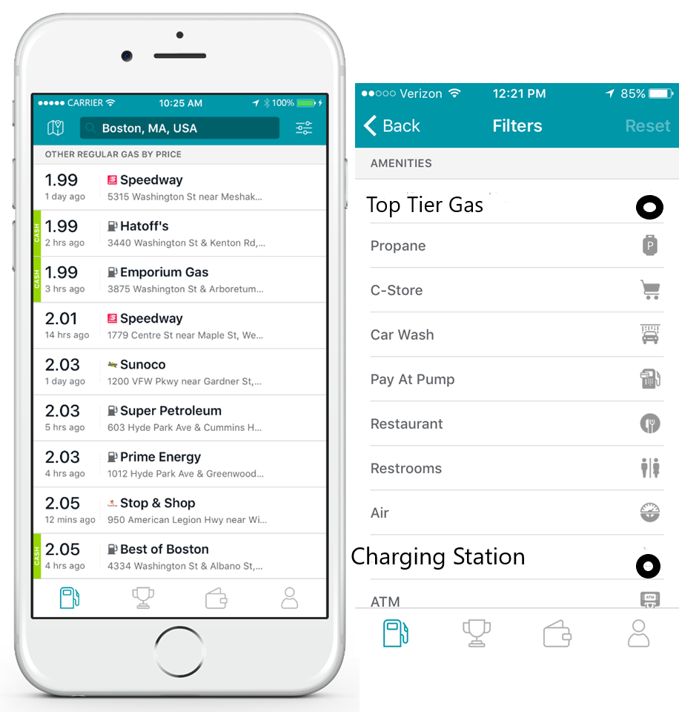

Appendix E

Charging Station Locations on Map

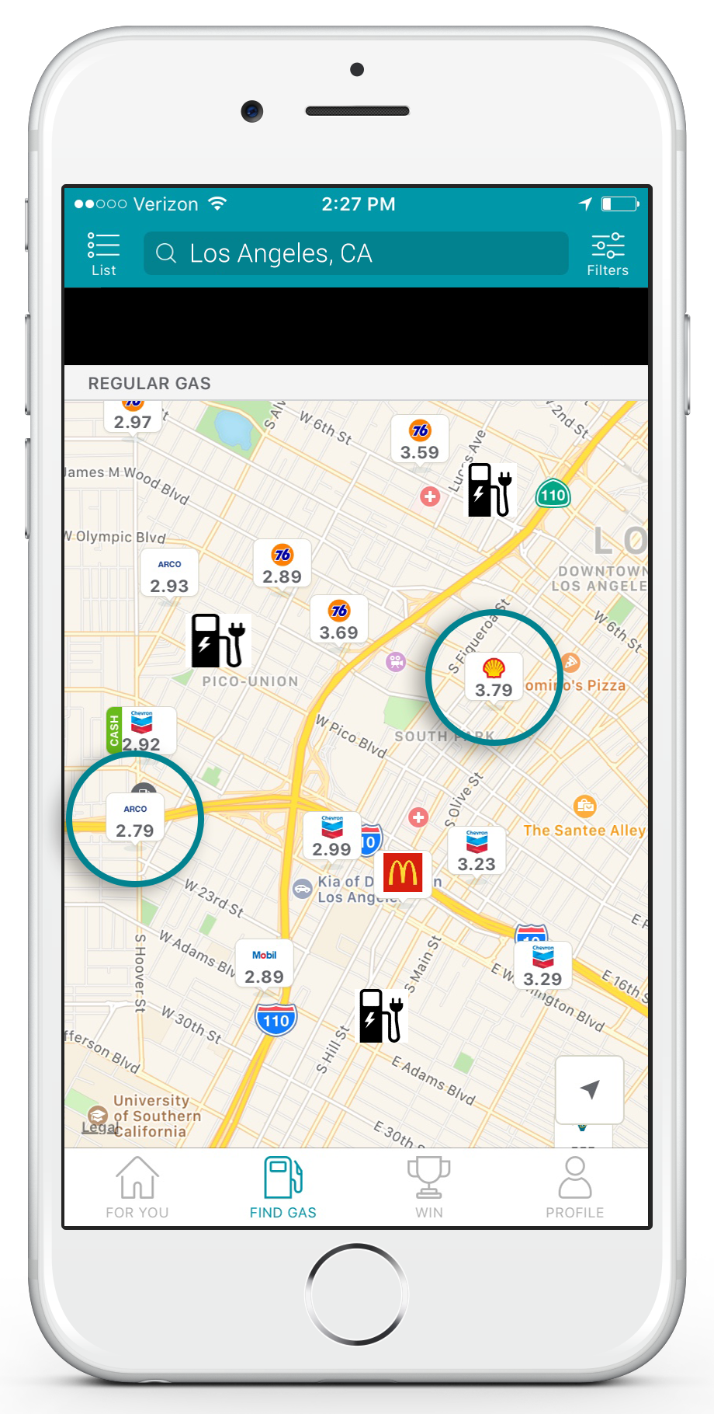

Appendix F

Main Screen screenshot

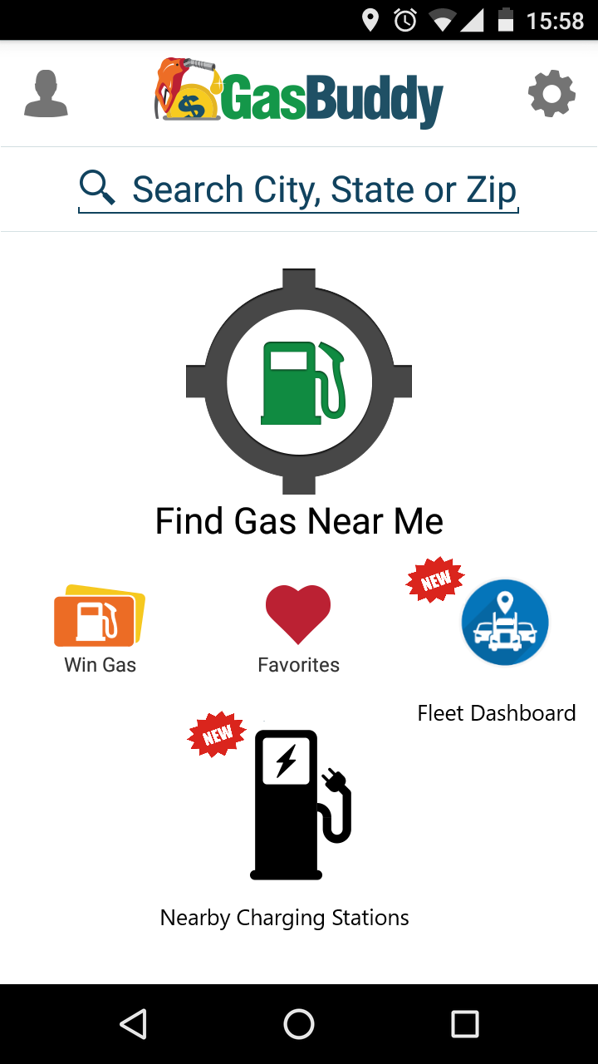

**Appendix G**

**Project Status Report**

GasBuddy 3.0

Project Status Report

|  |
| --- |
| Project Name: GasBuddy 3.0 |
| Date: |
| Project Manager: Craig Daniels |

# 1.0 Milestones and Schedule Dates

|  |  |  |
| --- | --- | --- |
| **Milestones** | **Estimated Completion Date** | **Percent**  **Complete** |
|  |  |  |

# 2.0 Accomplishments This Period

## 2.1 Activities

## 2.2 Activities Planned But Not Achieved

## 2.3 Deliverables Completed

## 2.4 Deliverables Planned But Not Completed

# 3.0 Accomplishments Planned for Next Period

## 3.1 Activities

## 3.2 Deliverables

# 4.0 To Date Earned Values

|  |  |  |  |  |  |  |  |  |
| --- | --- | --- | --- | --- | --- | --- | --- | --- |
|  | PV | AC | EV | CV | SV | CPI | SPI | EAC |
| Current |  |  |  |  |  |  |  |  |

|  |  |  |
| --- | --- | --- |
| * Earned Value Indicators: | | |
| * PV = Planned Value or Budgeted Cost of Work Scheduled * AC = Actual Cost of Work Performed * EV = Earned Value or Budgeted Cost of Work Performed, | * CV = Cost Variance * SV = Schedule Variance * CPI = Cost Performance Index | * SPI = Schedule Performance Index * EAC = Estimate at Completion |

**GasBuddy 3.0**

# 5.0 Risks and Issues Summary

## 5.1 New

|  |  |  |  |
| --- | --- | --- | --- |
| Risk/Issue # | Description | Action | Owner |
|  |  |  |  |
|  |  |  |  |
|  |  |  |  |

## 5.2 History

|  |  |  |  |
| --- | --- | --- | --- |
| Risk/Issue # | Description | Status  (Open/Closed) | Owner |
|  |  |  |  |
|  |  |  |  |
|  |  |  |  |

# Change Request Summary

|  |  |  |  |
| --- | --- | --- | --- |
| Change ID # | Description | Change Request Type  (Defect Repair, Enhancement, Addition, etc.) | Status |
|  |  |  |  |
|  |  |  |  |
|  |  |  |  |